caBIG® Integration Hub

Technical Architecture Guide

Last Modified: 6/21/2010

Author : Mukesh Mediratta, Charles Griffin
Team : caBIG® Integration Hub

Client : National Cancer Institute - Center for Bioinformatics,
National Institutes of Health,
US Department of Health and Human Services

Document History

Document Location
The most current version of this document is located in Subversion.

Revision History
Version Number | Revision Date | Author | Summary of Changes
1.0 | 12/22/2010 | Ajay Nalamala | New Document

Review
Name | Team/Role | Version | Date Reviewed | Reviewer Comments

Related Documents
More information can be found in the following related documents:
Document Name

TABLE OF CONTENTS
caBIG® Integration Hub 1
Technical Architecture Guide 1
Version No: 2.2 1
Document History 2
Document Location 2
Revision History 2
Review 2
Related Documents 3
1 Introduction 8
1.1 Chapter Organization and Content 8
1.2 Overview of the Guide 8
1.3 Organization of the Guide 8
1.4 Intended Audience for the Guide 9
1.5 Scope of the Guide 9
1.6 Document Text Conventions 9
1.7 Related documents 10
2 Overview of the Software 11
2.1 Chapter Organization and Content 11
2.2 Software Overview 11
2.2.1 Project Background 11
2.2.2 System Overview 11
2.2.3 Features of the caBIG® Integration Hub 12
2.3 System Requirements 12
3 caBIG® Integration Hub Installation 14
3.1 Installation scripts 14
3.2 installation verification 14
4 caBIG® Integration Hub Architecture 15
4.1 Chapter Organization and Content 15
4.2 System Architecture Overview 15
4.3 Architectural Design 17
4.3.1 Asynchronous Invocation 18
4.3.2 Synchronous Invocation 19
5 caBIG® Integration Hub Design 22
5.1 Chapter Organization and Content 22
5.2 caBIG® Integration Hub 22
5.2.1 Use Cases 22
5.2.2 Logical Design 25
5.2.2.1 caBIG® Integration Hub Inbound Grid Service 25
5.2.2.2 Operations 25
5.2.2.3 Response Listener 25
5.2.2.4 caBIG® Integration Hub Service Assembly 26
5.2.2.5 Asynchronous Invocation 28
5.2.2.6 Synchronous Invocation 32
5.2.2.7 Authentication/Authorization 34
5.2.2.8 Audit Listener 37
5.2.2.9 caBIG® Integration Hub Consumer Service 38
5.2.2.10 Configuration Items 39
5.2.3 Sequence Diagrams 39
5.2.3.1 Successful Flow Sequence Diagram (Asynchronous) 39
5.2.3.2 Rollback Flow Sequence Diagram 41
5.2.4 Deployment Diagram 42
5.3 Technology Stack 43
Technical Manuals/Articles 45
caBIG® Material 45
caCORE Material 45
List of Figures
Figure 1 caBIG® Integration Hub 2.2 High Level Data Flow 17
Figure 2 caBIG® Integration Hub Component Diagram 18
Figure 3 Overall flow for Asynchronous Invocation 19
Figure 4 Overall flow for a synchronous invocation of caBIG® Integration Hub 21
Figure 5 caBIG® Integration Hub use cases 24
Figure 6 caBIG® Integration Hub Administration use cases 25
Figure 7 caBIG® Integration Hub ResponseListener Class Model 27
Figure 8 caBIG® Integration Hub Service Assembly Components 28
Figure 9 caBIG® Integration Hub detailed design and workflow for asynchronous invocation of study creation message. 31
Figure 10 caBIG® Integration Hub detailed design and workflow for synchronous invocation of COPPA Services 34
Figure 11 Sequence diagram showing how caBIG® Integration Hub interacts with the delegation service. 37
Figure 12 caBIG® Integration Hub interactions to get caGrid credentials 38
Figure 13 caBIG® Integration Hub Successful Flow Sequence Diagram 41
Figure 14 caBIG® Integration Hub: Rollback Sequence Diagram 42
Figure 15 - caBIG® Integration Hub Deployment Diagram 44

List of Tables
Table 1 - Main Contents of the caBIG® Integration Hub Technical Architecture Guide 9
Table 2 - Document Conventions 10
Table 3 - Key Roles in the caBIG® Integration Hub Project 12
Table 4 - High Level Summary of Requirements 14
Table 5 caBIG® Integration Hub Grid Service Operations 26
Table 6 caBIG® Integration Hub Service Assembly Components (the numbers in the table refer to components in Figure 7). 32
Table 7 caBIG® Integration Hub Service Assembly Components for synchronous invocation (the numbers in the table refer to components in Figure 8). 34
Table 8 caBIG® Integration Hub Consumer Grid Service Operations 39

Introduction
The caBIG® Integration Hub is the enterprise service hub for exchanging clinical trial information between applications and systems. The caBIG® Integration Hub, which was originally called caXchange, is a generic platform for exchanging and transforming many types of clinical trials data and messages using service invocations and data exchange. It is also leveraged in the caBIG® Clinical Trials Suite project.
This Technical Architecture Guide provides the software architecture and high-level design for the caBIG® Integration Hub. This document is intended to guide the development team to develop a detailed design for the system, emphasizing the architecturally significant parts of the design model.

Chapter Organization and Content
The purpose of this chapter is to provide a high-level overview of the caBIG® Integration Hub solution, its components, and the overall content of this guide.
Topics in this chapter include:
- Overview of the Guide
- Organization of the Guide
- Scope of the Guide
- Document Text Conventions

Overview of the Guide
This guide introduces the technical and architectural aspects of the caBIG® Integration Hub version 2.3. It provides an overview of the architecture describes the components and their use cases; identifies the technology stack; and provides some technical reference.

Organization of the Guide
The table below provides a summary for each of the chapter’s focus.
Table 1 - Main Contents of the caBIG® Integration Hub Technical Architecture Guide
Chapters in caBIG® Integration Hub Technical Architecture Guide | Chapter Contents
Chapter 1 | Introduction
Chapter 2 | Overview of the Software
Chapter 3 | caBIG® Integration Hub Installation
Chapter 4 | caBIG® Integration Hub comes with integration smoke tests that can be used to verify Hub installation. These tests are also part of the integration smoke tests included with Suite bundle. Integration smoke test scripts can be used to send test messages to caBIG® Integration Hub. These messages verify the security infrastructure, payload validation and caBIG® Integration Hub routing. A separate document—the caBIG® Integration Hub Integration Smoke Test-User Guide—outlines the steps for using the integration smoke tests. Please refer to that document for details, the latest version of which can be found below:
Chapter 5
Chapter 6 | Error: Reference source not found
Appendix A | References
Appendix B | Glossary
Index | Index

Intended Audience for the Guide
The intended audience for this document includes developers and architects interested in obtaining an overview of the architecture and high-level design for the caBIG® Integration Hub.

Scope of the Guide
The scope of this document is limited to the requirements as identified in caBIG® Integration Hub solution version 2.3. For additional project and requirement-specific information, please refer to the following documents:
- caBIG® Integration Hub Software Requirements Specification (SRS)
- caBIG® Integration Hub Use Case Documents
Please visit the following web site for the latest versions of these documents:
https://ncisvn.nci.nih.gov/svn/iHub/trunk/docs/

Document Text Conventions
The following table shows various typefaces to differentiate between regular text and menu commands, keyboard keys, and text that you type, which illustrates how this guide represents conventions.
Table 2 - Document Conventions
Convention | Description | Example
Bold & Capitalized Command  Capitalized command > Capitalized command | Indicates a Menu command  Indicates Sequential Menu commands | Admin > Refresh
text in small caps | Keyboard key that you press | Press enter
text in small caps + text in small caps | Keyboard keys that you press simultaneously | Press shift + ctrl and then release both.
Special typestyle | Used for filenames, directory names, commands, file listings, source code examples and anything that would appear in a Java program, such as methods, variables, and classes. | URL_definition ::= url_string
Boldface type | Options that you select in dialog boxes or drop-down menus. Buttons or icons that you click. | In the Open dialog box, select the file and click the Open button.
Italics | Used to reference other documents, sections, figures, and tables. | caCORE Software Development Kit 1.0 Programmer’s Guide
Italic boldface type | Text that you type | In the New Subset text box, enter Proprietary Proteins.
Note: | Highlights a concept of particular interest | Note: This concept is used throughout the installation manual.
Warning! | Highlights information of which you should be particularly aware. | Warning! Deleting an object will permanently delete it from the database.
{} | Curly brackets are used for replaceable items. | Replace {root directory} with its proper value such as c:\cabio

Related documents
For additional project information, please refer to the following documents:
- caBIG® Integration Hub Software Requirements Specification (SRS)
- caBIG® Integration Hub Use Case Specification and Realization Document
- caBIG® Integration Hub Design Document
- caBIG® Integration Hub Installation Guide
- caBIG® Integration Hub Administration Guide
Please visit the following web site for the latest versions of these documents:
https://ncisvn.nci.nih.gov/svn/iHub/trunk/docs/

Overview of the Software

Chapter Organization and Content
This chapter covers the following topics:
- Project Background
- System Overview
- Features of the caBIG® Integration Hub
- System Requirements

Software Overview

Project Background
The caBIG® Clinical Trials Suite of applications needs to be able to exchange information among them in an audited and controlled manner. The caBIG® Integration Hub provides this capability by using standard service hub protocols and messaging formats to receive, route, transform, validate, log, and send messages and data between applications.
This project focuses on the development of an open-source, caBIG® compatible solution to support the exchange of data collected during a clinical trial. caBIG® Integration Hub will also provide integration with the NCI Person, Organization and Protocol Abstraction enterprise services. The resulting solution is intended to be stand-alone and caBIG® silver-level compatible.

System Overview
The goal of this project is to build a hub system that can route messages based on a standard format and that can extend to use other messaging formats needed by the cancer centers. As the caBIG® program is the primary sponsor, all work performed for this project must be done in compliance with the caBIG® principles of open source, open development, open access, and federation. Software that is used and/or developed in the context of this project must be caBIG® compatible at the silver-level (https://cabig.nci.nih.gov/guidelines_documentation/caBIGCompatGuideRev2_final.pdf) and must be made available to the community through resources provided by the General Contractor.
The following table defines the key roles in the project:
Table 3 - Key Roles in the caBIG® Integration Hub Project
Role | Name | Comments
Project Sponsor | caBIG®
Reviewer | caBIG® Architecture Workspace | Reviews and provides guidance of architecture artifacts
Reviewer | caBIG® Lab SIG | Provides requirements feedback
User | NCICB | Hosts the caXchange
Developer | Ekagra Software Technologies | Development team

Features of the caBIG® Integration Hub
The following are the key features of the caBIG® Integration Hub solution:
- Contains a service oriented flexible and extensible architecture
- Built on open source ESB technology – Apache ServiceMix
- Built using reusable Java Business Integration (JBI) components that can be deployed to any JBI container
- Supports message routing and customized workflows.
- Uses externalized configuration to configure caBIG® Integration Hub to add/remove target services
- Provides ability to configure new service types in addition to the services configured for caBIG® Clinical Trials Suite
- Provides payload validation using schemas defined in Global Model Exchange
- Transforms messages using Saxon XSLT transformation engine.
- Integrates with NCI Correlation, Organization, Person and Protocol Abstraction enterprise services
- Integrates in a non-grid environment using WSDL interface with WS-Security
- Provides a simplified single command installation script to install all caBIG® Integration Hub components
- Provides integration smoke tests to verify caBIG® Integration Hub and caBIG® Clinical Trials Suite installation
- Supports user authentication and delegation using caGrid Services.
- Provides a Log Locator Tool to view the message exchange status
- Integrates with Generic Clinical Connector to enable integration with CDMS

System Requirements
The following table provides a very high-level summary of the caBIG® Integration Hub system’s requirements:
Table 4 - High Level Summary of Requirements
Requirement ID | Requirement Description
1.0 | Must provide the ability to receive and route CT Laboratory Observation Periodic Report in HL7v3 format to various external systems.
2.0 | Must provide the ability to monitor the caBIG® Integration Hub activities and perform administrative functions on the caBIG® Integration Hub.
3.0 | Must provide architectural and user documentation for the technical components developed by the caBIG® Integration Hub technical team.
4.0 | Must allow communication of non-grid applications on caBIG® Integration Hub ESB to Grid Services or Grid Clients
5.0 | Must be enhanced to automate custom workflow by routing rules in the database to provide routing to multiple services and support itinerary based routing.
6.0 | Must provide an ability to transform messages using XSL style sheets; administrators should be able to configure and update transformations in deployed caBIG® Integration Hub environments.
7.0 | Should provide a configurable optional message validation.
8.0 | Should provide integration with NCI Person, Organization and Protocol Abstraction Enterprise services.
9.0 | Should expose a secure non-grid interface.
10.0 | Must contain build and installation scripts that comply with the NCI CBIIT Build and Deployment Automation (BDA) framework.

The caBIG Integration Hub requirements are detailed in the software requirements and specifications document. The following is the URL to this document:
https://ncisvn.nci.nih.gov/svn/cabigintegrationhub/trunk/docs/Requirements/

caBIG® Integration Hub Installation

Installation scripts
A separate document—the caBIG® Integration Hub Installation Guide—outlines the steps for installing and configuring various components that comprise the caBIG® Integration Hub solutions. The caBIG® Integration Hub installation has been streamlined using scripts generated with the NCI CBIIT Build and Deployment Automation (BDA) scripts. BDA compatible installation scripts are provided to install and configure various caBIG® Integration Hub components. Please refer to the installation document for details, the latest version of which can be found below:
https://ncisvn.nci.nih.gov/svn/cabigintegrationhub/trunk/docs/installation/

installation verification
caBIG® Integration Hub comes with integration smoke tests that can be used to verify Hub installation. These tests are also part of the integration smoke tests included with Suite bundle. Integration smoke test scripts can be used to send test messages to caBIG® Integration Hub. These messages verify the security infrastructure, payload validation and caBIG® Integration Hub routing. A separate document—the caBIG® Integration Hub Integration Smoke Test-User Guide—outlines the steps for using the integration smoke tests. Please refer to that document for details, the latest version of which can be found below:
https://ncisvn.nci.nih.gov/svn/cabigintegrationhub/trunk/docs/Testing

caBIG® Integration Hub Architecture

Chapter Organization and Content
This chapter covers the following topics:
- System Architecture Overview
- Architectural Design

System Architecture Overview
- caBIG® Integration Hub provides the ability to route requests from multiple originating systems to various destinations. These destinations are different services and applications that are configured to resume the requests. These applications/services can potentially require the requests in different formats (BRIDG, HL7 or custom). They may also require the request communicated using different protocols such as http, ftp or jms.
- Figure 1 shows a high-level view of the flow of data that will take place in caBIG® Integration Hub. This figure shows that caBIG® Integration Hub will receive requests from different sources and then route them to various targets based on the type of request.
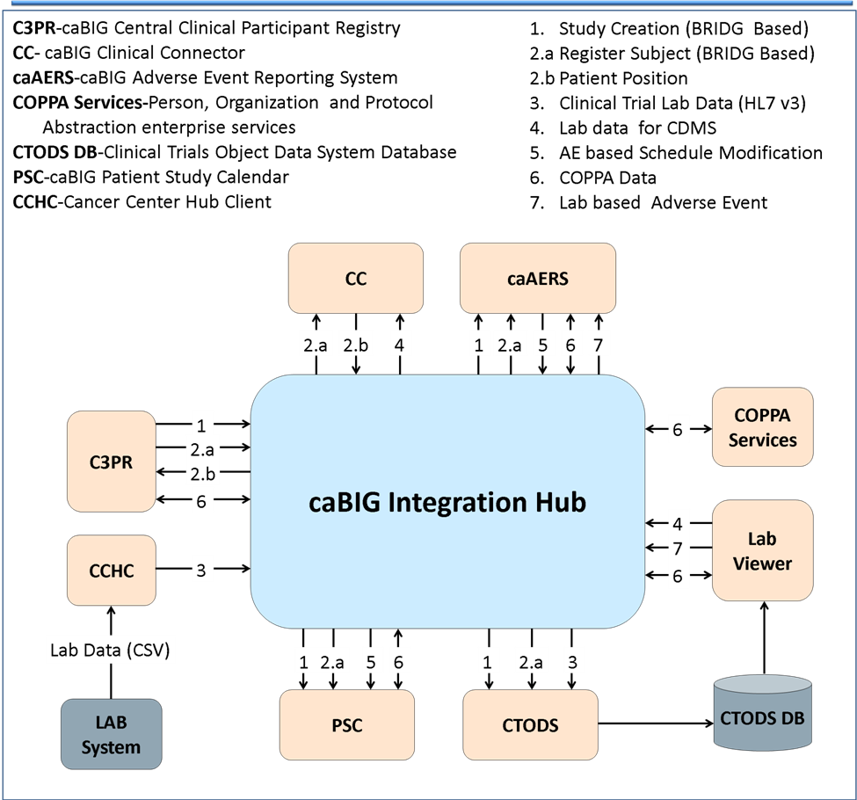
Figure 1 caBIG® Integration Hub 2.2 High Level Data Flow

Architectural Design
caBIG® Integration Hub uses Apache ServiceMix open source Enterprise Service Bus (ESB) services and components. Additional customized components have been written and deployed on the Apache Servicemix ESB to provide routing and transformation services.
The following diagram depicts the high-level components in caBIG® Integration Hub:
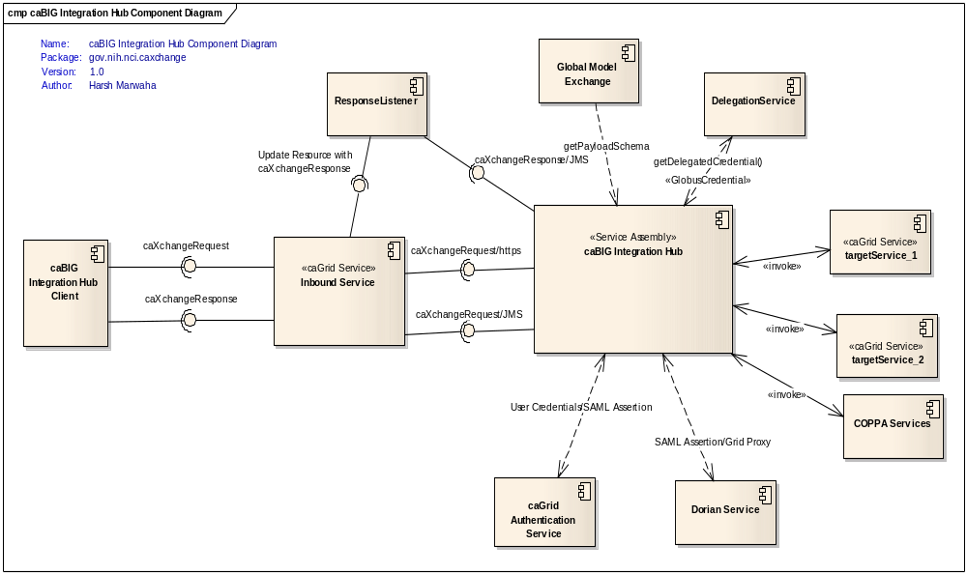
Figure 2 caBIG® Integration Hub Component Diagram
Architectural components in the component diagram featured above are explained below:
caBIG® Integration Hub Client: This is a caGrid-based web service client that can be used to send requests to the hub. The interface provided to the client is described in the caBIG® Integration Hub interface specification.
Inbound Service: This is a caGrid service that provides a caGrid compatible interface to the caBIG® Integration Hub. This service acts as a proxy to the hub, forwarding requests to the hub for processing, as well as implementing the interface as specified in the caBIG® Integration Hub interface specification.
caBIG® Integration Hub: This is the main service assembly component deployed on Apache Servicemix. It is responsible for all the hub services including payload validation, delegation lookup, auditing and reliable transactions, as well as invoking the target services.
Response Listener: This component resides with the inbound service and listens to responses from the caBIG® Integration Hub, which facilitates asynchronous invocation of the hub.
Global Model Exchange: A caGrid global model exchange service that acts as a repository of schemas for payload validation.
Delegation Service: A caGrid credential delegation service is used to look up delegated credentials for invoking secure target services.
Target Services: caGrid target services are configured to be invoked by caBIG® Integration Hub.

Asynchronous Invocation
The following diagram depicts how the components described above are used for an asynchronous invocation of caBIG® Integration Hub:

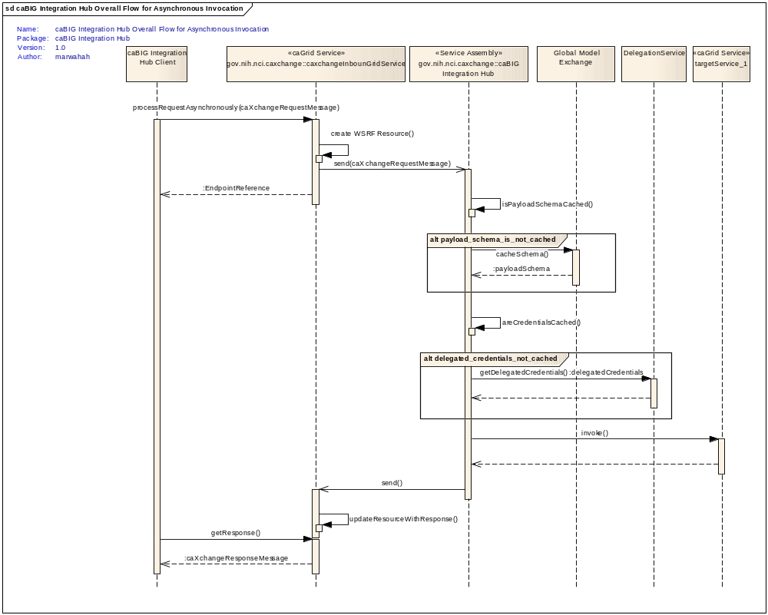
Figure 3 Overall flow for Asynchronous Invocation
- A caBIG® Integration Hub client sends a caXchangeRequest message to inbound grid service.
- caBIG® Integration Hub inbound grid service acts as a proxy for the caBIG® Integration Hub service assembly deployed on the Servicemix JBI (Java Business Integration) container.
- caBIG® Integration Hub inbound grid service for asynchronous processing creates a WS-Resourceframework resource associated with the caXchangeRequest. The inbound grid service then pushes the caXchangeRequest message to the JMS inbound component of hub service assembly. The bgHub service assembly takes over the processing of the request.
- The Integration Hub service assembly then validates the payload against the schema for the caBIG® Integration Hub service type. Integration Hub looks for the payload schema in the local cache. If the schema is not available in the local cache, then it is retrieved from the global model exchange.
- The Integration Hub service assembly then invokes the delegation service for the authorization credentials before routing the request message based on the message type.
- Integration Hub then routes the message to target services.
- Responses from the target services are then aggregated into a caXchangeResponse message.
- Response listeners get the caXchangeResponse from the hub service assembly and updates the WS-Resourceframework resource associated with the caXchangeRequest.
- Inbound services then make the response available to the client.

Synchronous Invocation
The following diagram describes how the Integration Hub components can be used for a synchronous invocation of caBIG® Integration Hub:
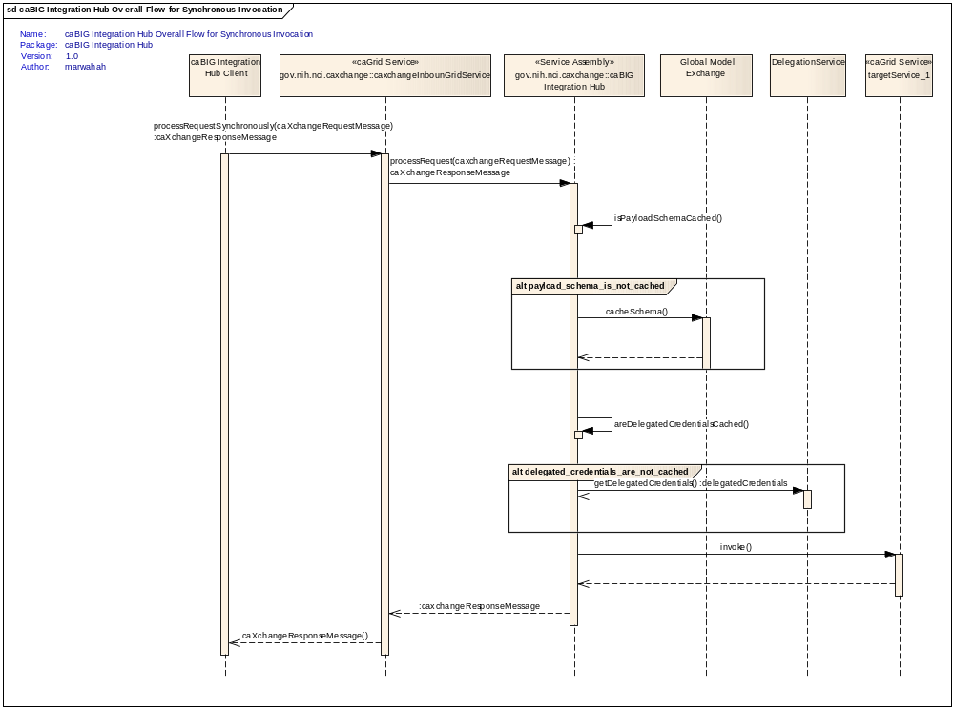
Figure 4 Overall flow for a synchronous invocation of caBIG® Integration Hub
- A caBIG® Integration Hub client sends a caXchangeRequest message to the inbound grid service.
- caBIG® Integration Hub inbound grid service acts as a proxy for the caBIG® Integration Hub service assembly deployed on the Servicemix JBI (Java Business Integration) container.
- Inbound Grid Service for synchronous processing invokes the http binding component of the caBIG® Integration Hub service assembly. The http binding component is a WSDL interface to caBIG® Integration Hub service assembly, which takes over the processing of the request.
- caBIG® Integration Hub service assembly then validates the payload against the schema for the caBIG® Integration Hub service type. caBIG® Integration Hub looks for the payload schema in the local cache. If the schema is not available in the local cache, then it is retrieved from global model exchange.
- caBIG® Integration Hub service assembly then invokes the delegation service for the authorization credentials before routing the request message based on the message type. (Please refer to the caBIG® Integration Hub detailed design diagram for routing details.). Outbound components then invoke the target services.
- Responses from the target services are then aggregated into a caXchangeResponse message
- Integration Hub service assembly then routes the caXchangeResponse to the http binding component that sends it to the inbound service.
- Inbound service sends the response to the client.

caBIG® Integration Hub Design

Chapter Organization and Content
This chapter includes the following topics:
- caBIG® Integration Hub Design
- Technology Stack

caBIG® Integration Hub
The caBIG® Integration Hub is defined as the software component that is primarily responsible for receiving input from various external systems, routing the input to various services that are hosted on the grid, and eventually routing the output of those services to external systems. The caBIG® Integration Hub is based on Apache ServiceMix, which is an Enterprise Service Bus (ESB) built to the Java Business Integration (JBI) specification.

Use Cases
The following diagrams show the use cases and actors. For more details on the use cases, please refer to the caBIG® Integration Hub Enterprise Architect Use Case Model.
https://ncisvn.nci.nih.gov/svn/cabigintegrationhub/trunk/docs/Requirements/.

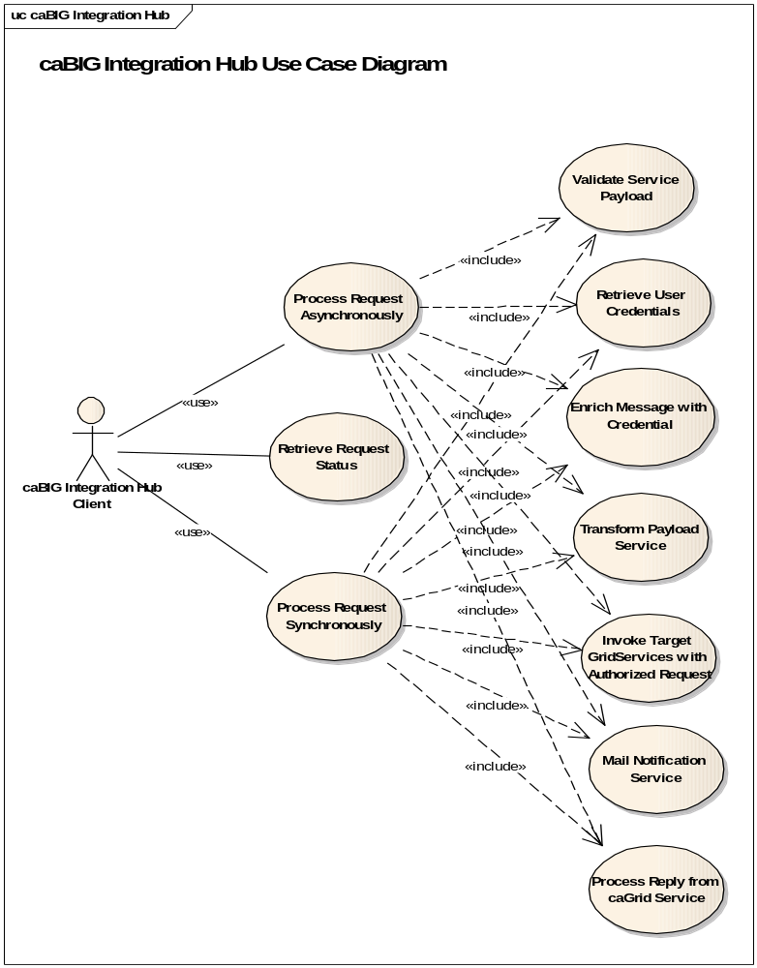
Figure 5 caBIG® Integration Hub use cases
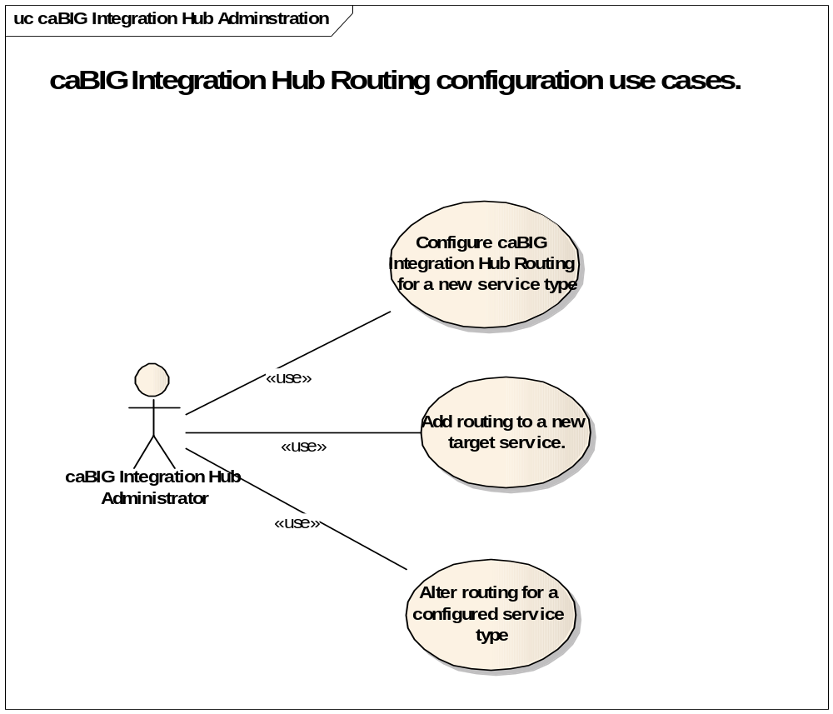
Figure 6 caBIG® Integration Hub Administration use cases

Logical Design

caBIG® Integration Hub Inbound Grid Service
The caBIG® Integration Hub grid service acts as a proxy for Integration Hub service assembly, which provides a caGrid-based service interface to Integration Hub. The caBIG® Integration Hub inbound service pushes the incoming requests to the inbound JMS queue from where the Integration Hub service assembly picks it up for further processing. To keep track of a request it creates a WS-Resource framework resource. The grid service returns an EndPointReference to the client. The client then uses this end point reference to invoke the getResponse operation. The grid service also creates a response listener, which listens for responses from the service assembly. Once a response is received, the inbound grid service updates the resource with the response. Please see the caBIG® Integration Hub interface specification document for details of the operations it exposes.

Operations
Table 5 caBIG® Integration Hub Grid Service Operations
Method | Notes | Parameters | Return
ProcessRequestAsynchronously | Processes a caXchangeRequest | CaXchangeRequest | CaXchangeContextReference
ProcessRequestSynchronously | Processes a caXchangeRequest synchronously | CaXchangeRequest | caXchangeResponse
getResponse | Gets the caXchangeResponse if it is ready, otherwise throws an Exception | None | caXchangeResponse

Response Listener
The caXchangeResponse listener lives with the caBIG® Integration Hub grid service and listens for the response on the JMS queue associated with the response outbound component of the caBIG® Integration Hub service assembly. Once a response is received from the queue, the resource associated with the corresponding request is updated. The client can then use the getResponse method to get the caXchangeResponse. The caXchangeResponse listener and the WS-Resource-based resource for invoking caXchange are only used during asynchronous processing.
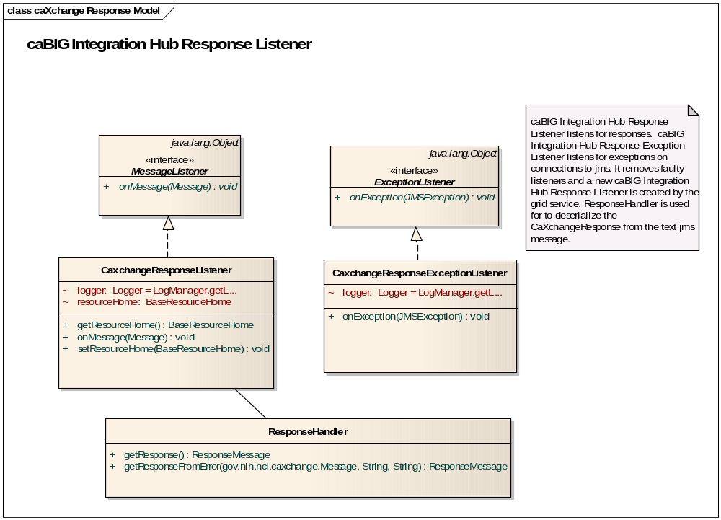
Figure 7 caBIG® Integration Hub ResponseListener Class Model

caBIG® Integration Hub Service Assembly
A service assembly is a Java Business Integration (JBI)-based document that describes the routing, artifacts, and services that make up a SOA application. The caBIG® Integration Hub service assembly is deployed on the Apache Servicemix JBI container. The caBIG® Integration Hub service assembly component diagram shows the JBI and servicemix components that make up the caBIG® Integration Hub service assembly:
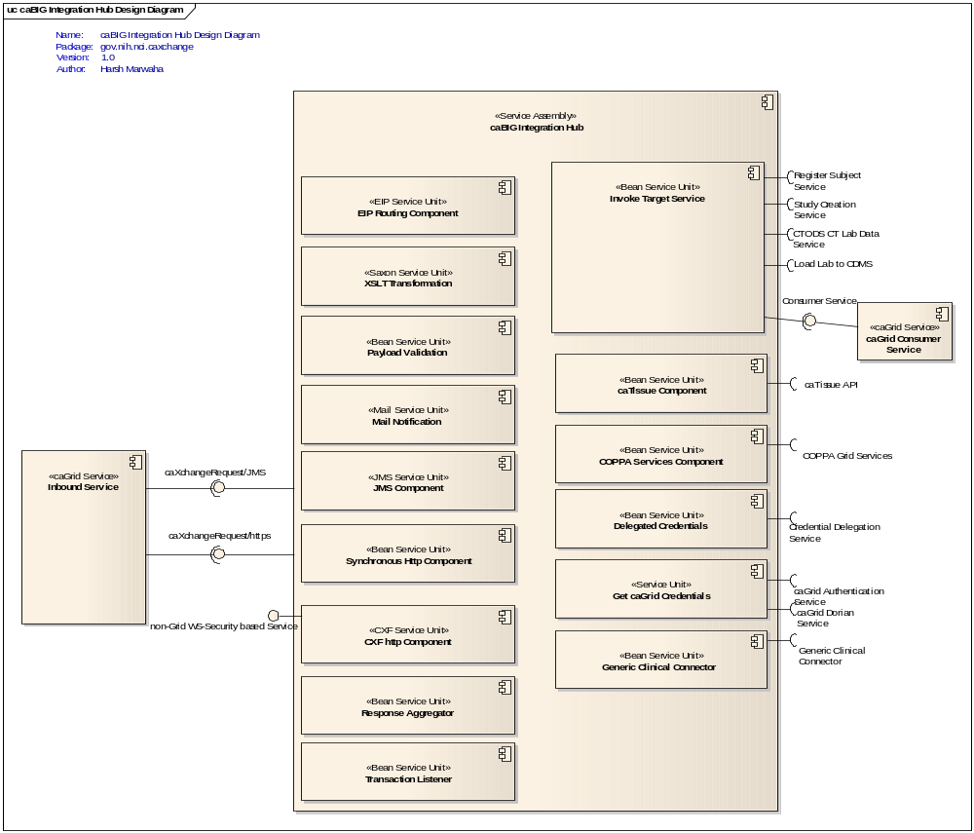
Figure 8 caBIG® Integration Hub Service Assembly Components
The caBIG® Integration Hub service assembly components that provide various functionality are described in the Integration Hub design document, which you can find at:
https://ncisvn.nci.nih.gov/svn/cabigintegrationhub/trunk/docs/Design/caBIG%20Integration%20Hub%20Design%20Document.doc

Asynchronous Invocation
The caBIG® Integration Hub service assembly uses the Enterprise Integration Pattern (EIP) service unit to define the routing of the messages within caBIG® Integration Hub. The caBIG® Integration Hub design diagram below gives the detailed design of the caBIG® Integration Hub service assembly and how the components within caBIG® Integration Hub are used to route the study creation message.
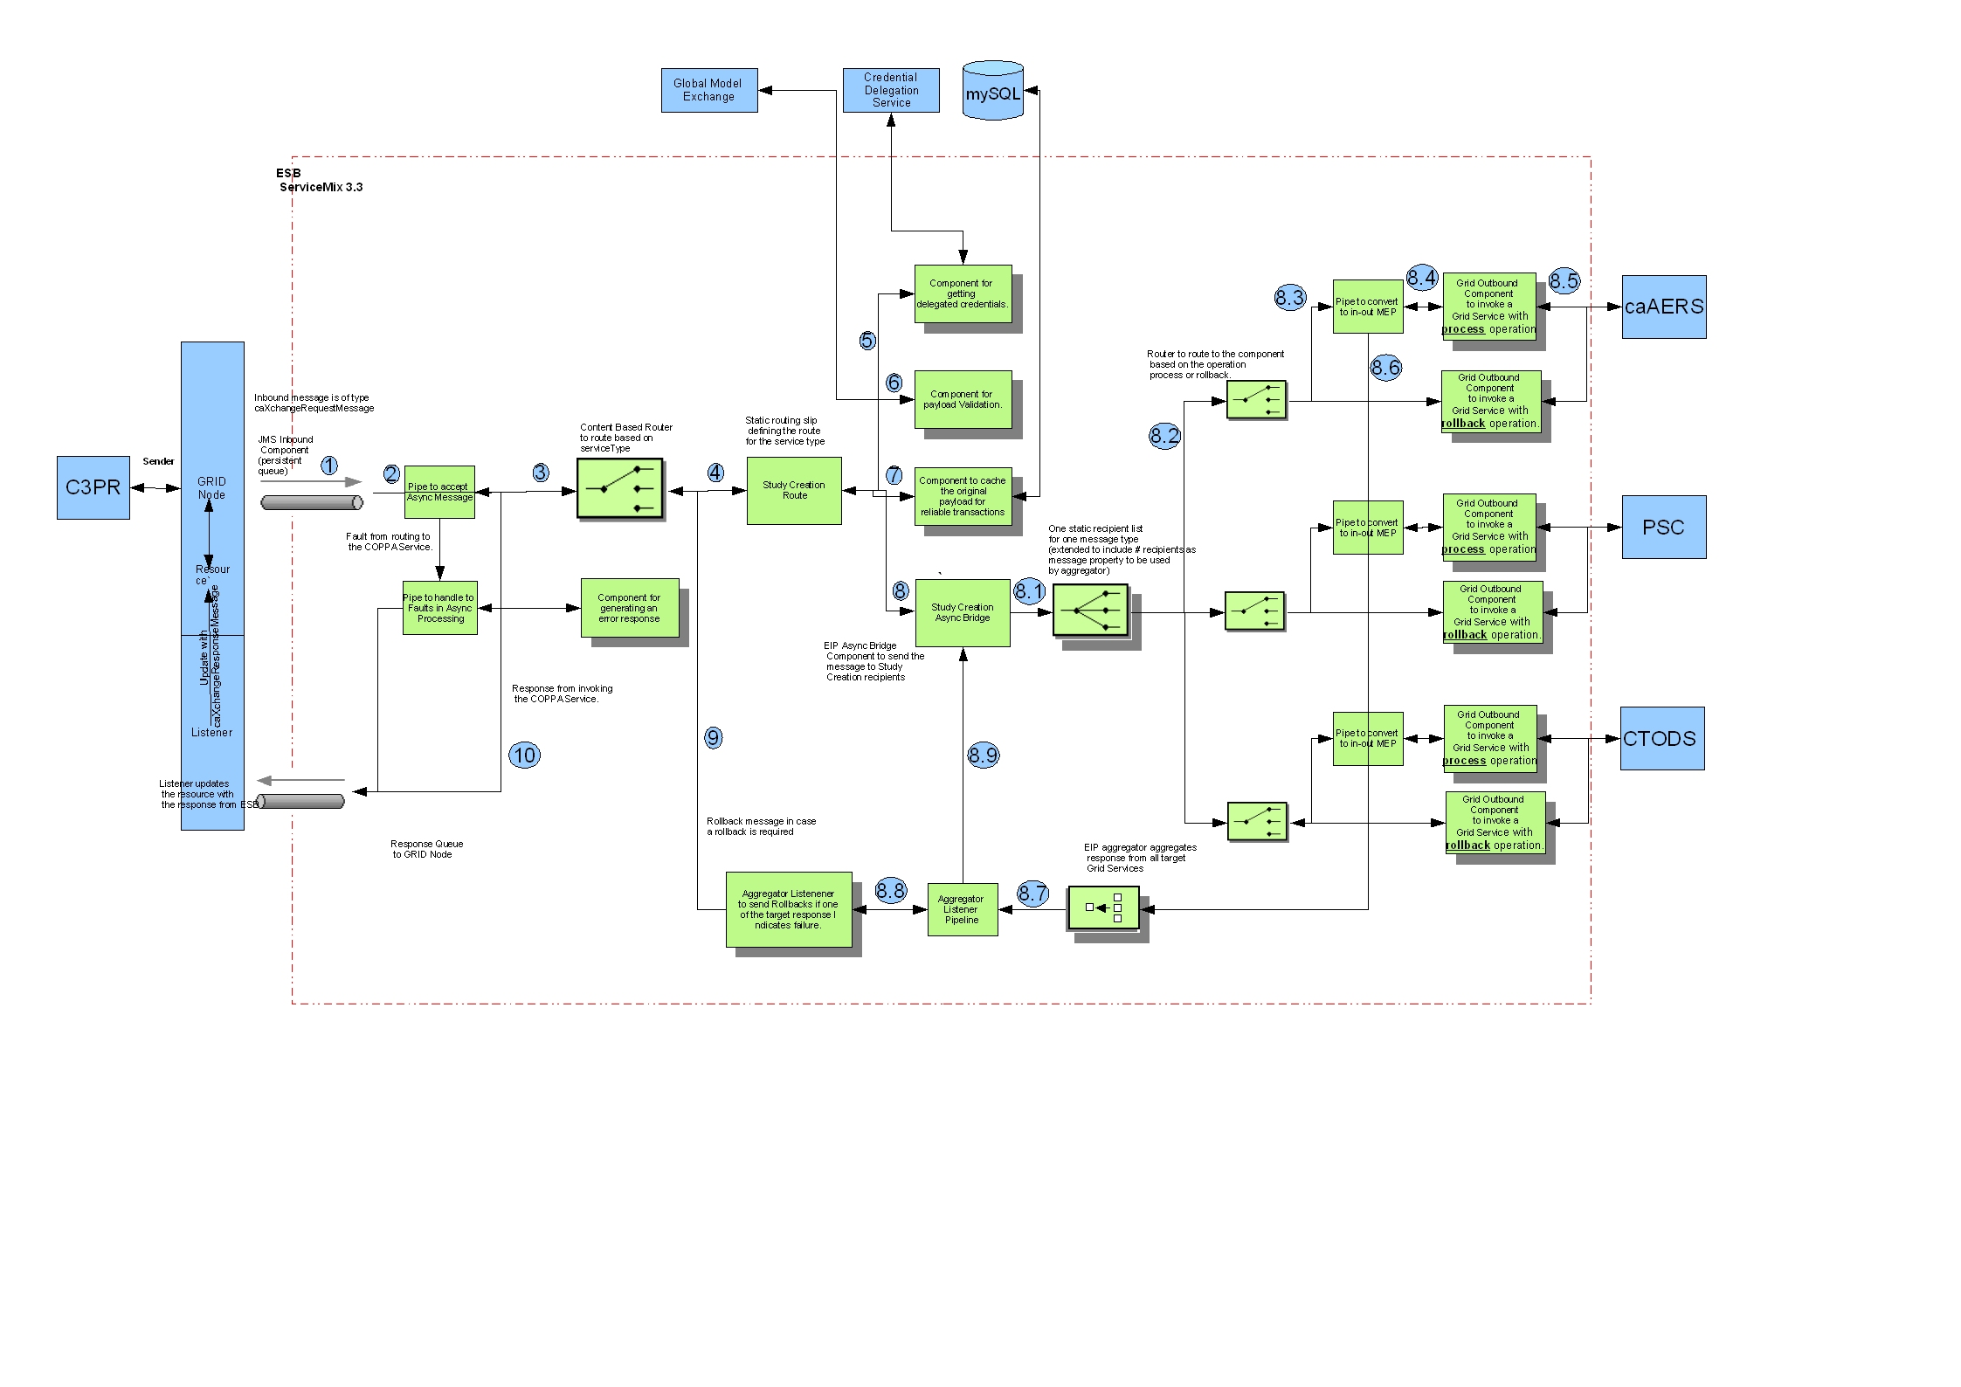
Figure 9 caBIG® Integration Hub detailed design and workflow for asynchronous invocation of study creation message.
A more readable image of the diagram can be found at:
https://ncisvn.nci.nih.gov/svn/cabigintegrationhub/trunk/docs/Design/design-diagram-studycreation-async.png
The following table describes the caBIG® Integration Hub service assembly components. Numbers in the component column refer to the number in the above caBIG® Integration Hub design diagram given to an exchange going into that component.
Table 6 caBIG® Integration Hub Service Assembly Components (the numbers in the table refer to components in Figure 7).
Component | Type | Purpose
1. InboundComponent | JMS | Receives inbound caXchangeRequest messages.
2. Pipeline to accept the asynchronous message and convert to an IN-OUT exchange. | EIP | Receives the asynchronous in-only exchange and converts it to an in-out exchange for invoking the target services.
3. Content-Based Router | EIP | Routes the message based on the service type to the right component handling the service specified in the message metadata.
4. Study Creation Router | EIP | Defines the routes for the study creation message. This is defined using a static routing slip. The static routing slip includes routes for all the target services that will consume the study creation message. Target services can be added to this component for receiving the study creation message. Target services can be removed if they are no longer interested in receiving the study creation message.
5. Getting Delegated Credentials | Bean | Invokes the credential delegation service and gets the delegated credentials, which are then set as the JAAS subject to be used for invoking the target service.
6. Payload Validation Service | Bean | Validates the message payload against the configured message schema; the validation schema can be obtained from the GME or the file system.
7. Cache Original Message for reliable transactions | Bean | Caches the original message, which is done if the original message is required to be sent for rollbacks/reliable transactions.
8. Study Creation Async Bridg | EIP | Groups together the route for messages for service types that are sent to multiple target services.
8.1. Static Recipient List | EIP Customized | Sends the message to multiple recipients for invoking target services, which is customized to add a message property for number of recipients
8.2. Content-Based Router | EIP | Routes messages based on the operation. If the operation name value is “PROCESS” the message is routed to a pipeline to invoke the service and get a response. If the operation name value is “ROLLBACK” the message is send without expecting a response as an in-only message exchange.
8.3. Pipeline | EIP | Invokes target service as an in-out message exchange.
8.4. Outbound Component | Bean | Invokes the target grid service.
8.5. Aggregator | EIP Customized | Aggregates responses from multiple target services, which is customized to work with the customized static recipient list in #6 above.
8.6. Pipeline | EIP | Invokes the aggregator listener component.
8.7. Aggregator Listener | Bean | Listens for aggregated responses from target services. Once the aggregated response is received it does the following two steps:  - Looks at the response and the message type to verify if a rollback is required. If required, a message with the rollback is sent to the service type content-based router #9 for rollbacks.  - Creates a caXchangeResponse and sends it to the async bridge component for sending it back to the client #8.8.
8.8. Study Creation Async Bridg | EIP | Gets the response from the aggregator listener and coordinates with the original request to send it back to the client.

Synchronous Invocation
Additionally, caBIG® Integration Hub provides an ability to be invoked synchronously. These synchronous invocations are used to invoke the COPPA enterprise services in CCTS. The diagram below describes in detail the synchronous invocation design and workflow.
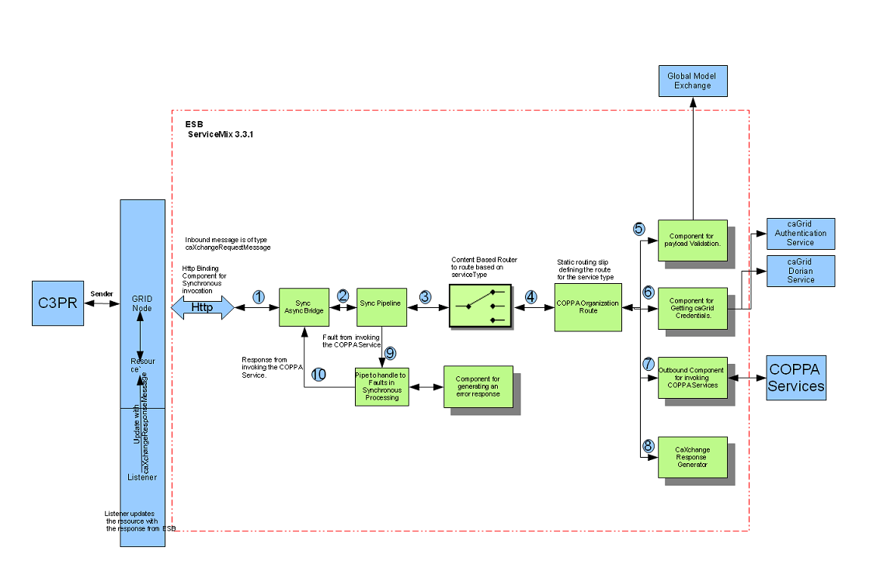
Figure 10 caBIG® Integration Hub detailed design and workflow for synchronous invocation of COPPA Services
A more readable image of the diagram can be found at:
https://ncisvn.nci.nih.gov/svn/cabigintegrationhub/trunk/docs/Design/design-diagram-coppa-sync.png
The following table describes the caBIG® Integration Hub service assembly components used in the synchronous invocation of COPPA services. Numbers in the component column in Table 7 below refer to the number given to an exchange in Figure 10 Integration Hub design diagram.
Table 7 caBIG® Integration Hub Service Assembly Components for synchronous invocation (the numbers in the table refer to components in Figure 8).
Component | Type | Purpose
1. Synchronous Async Bridg | EIP | Accepts requests from the http binding component; converts the request to asynchronous so that the same routing can be used for both types of requests within caBIG® Integration Hub.
4. Pipeline to accept the asynchronous message and convert to an IN-OUT exchange. | EIP | Receives the asynchronous in-only exchange and converts it to an in-out exchange for invoking the target services; routes any faults to a fault handler.
3. Content-Based Router | EIP | Routes the message based on the service type to the right component handling the service specified in the message metadata.
4. Organization Router | EIP | Defines the route for the service. Includes all the components that need to be invoked for this service.
5. Payload Validation Service | Bean | Validates the message payload against the configured message schema; the validation schema can be obtained from the GME or the file system.
6. Component to get caGrid Credentials | Bean | Invokes the caGrid Authentication Service and the caGrid Dorian Service to get caGrid credentials for invoking secure COPPA services.
7. Outbound Binding Component | Bean | Invokes the secure COPPA service specified in the message meta data.
8. Generate Response | Bean | Creates a caBIG® Integration Hub response from the response returned from the COPPA service.
9. Pipe to handle faults | EIP | Invokes a handle error response service that creates a caBIG® Integration Hub response from the fault.
10. Synchronous Async Bridge | EIP | Correlates the response from COPPA service invocation with the original request and sends it back to the client.

Authentication/Authorization

Delegation Services
A delegation service is a WSRF-compliant grid service that enables users/services (delegator) to delegate their grid credentials to other users/services. Applications use it for passing on their credentials to caBIG® Integration Hub. This process is as follows:
- Each caXchangeRequest comes with an End Point Reference (EPR) pointing to a user’s delegated credentials and ID.
- caBIG® Integration Hub then looks for the Grid credentials in its local cache.
- If cached credentials are found and they are valid, then they are attached as a JAAS subject to the message.
- If cached credentials are not found, then caBIG® Integration Hub invokes delegation service using the delegated EPR.
- The delegation service returns back the user credentials (JAAS Subject), if the EPR is valid.
- caBIG® Integration Hub caches the credentials obtained from the delegation service.
- caBIG® Integration Hub attaches the JAAS Subject to the message.
- The outbound component then retrieves the JAAS subject and uses it to invoke the target grid services.
The sequence diagram below describes these interactions:
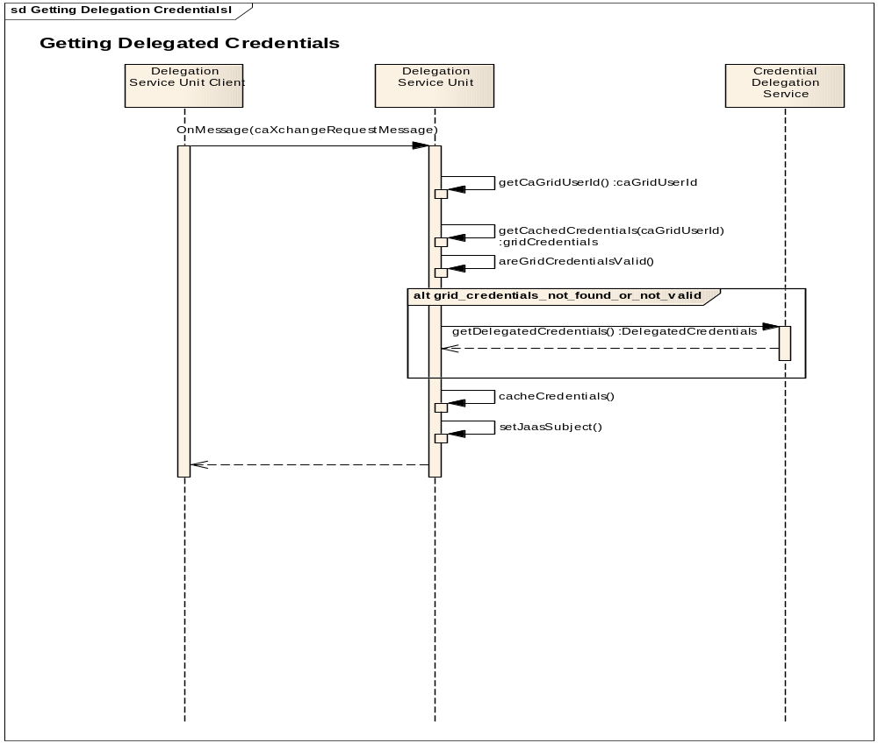
Figure 11 Sequence diagram showing how caBIG® Integration Hub interacts with the delegation service.

caGrid Authentication
caBIG Integration Hub includes components that provide for authentication that uses the caGrid security infrastructure services. These components can be used for non-grid applications to interact with secure grid services, which includes interactions with the caGrid authentication and dorian services to get caGrid credentials for invoking grid secured target services. The sequence diagram below describes this interaction:
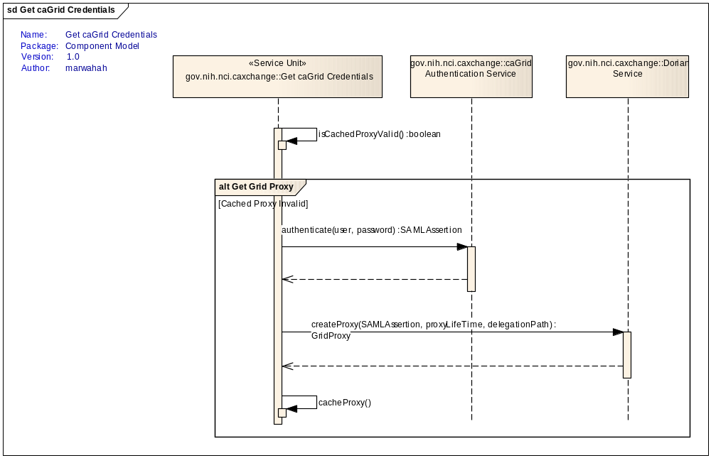
Figure 12 caBIG® Integration Hub interactions to get caGrid credentials
The component for getting caGrid credentials can use a configured caGrid user name and password to get caGrid X.509 certificate for invoking target services. The configured caGrid user acts as a proxy for the hub client to invoke secure target services. Each lookup of caGrid credentials requires two service calls; therefore, the credentials are cached for performance purposes.
The limitation of this component as compared to the delegation lookup is that the audit trail of the caGrid user from the client to the target service is lost as target services are invoked using configured credentials. However, this component provides flexibility in that it can be configured to invoke target services where it is not possible to provision multiple users to invoke target services. Additionally this component can be configured to invoke target services configured in different caGrid environments.

Audit Listener
The audit listener is implemented as a message exchange listener deployable on Apache Servicemix. This component will perform the following:
- Receives notification on each MessageExchange happening within caBIG® Integration Hub.
- Checks whether the message exchange received needs to be audited.
- Extracts the audit information and sends it to Common Logging Module (CLM) API for auditing, which then stores the audit information in the database and takes the messages from the database and displays on the Log Locator Tool (LLT).
Users on LLT can see messages only for the organization for which they are authorized. Also, the users can view messages based on the session ID, which is linked to the file name (along with a date/time stamp) sent in by the external clients.

caBIG® Integration Hub Consumer Service
The caBIG® Integration Hub consumer service is a caGrid-based service. This service provides a seamless integration for non-Grid target services using caGrid security, which is an optional component for caBIG® Integration Hub that can be used to implement target grid services. The caBIG® Integration Hub consumer service provides a skeleton into which business logic for target service can be plugged in. The interface implemented using the caBIG® Integration Hub consumer service is discussed below:

Operations
Table 8 caBIG® Integration Hub Consumer Grid Service Operations
Method | Notes | Parameters | Return
process | Processes a caXchangeRequest for the target system. | CaXchangeRequest | CaXchangeConsumerResponse
commit | Performs commit processing for the caXchangeRequest in the target system. | CaXchangeRequest
rollback | Rollbacks the changes related to the caxchangeRequest in the target system. | CaXchangeRequest

Configuration Items
The database location, target grid-services URLs, and JMS Queue locations are configurable items that are stored as properties in the conf/caxchange.properties file. Additionally, caBIG® Integration Hub has externalized its routing configuration, which enables hub administrators to configure Integration Hub for new service types, add routing to new target services, remove routing to target services, and configure payload validation. The caBIG® Integration Hub Administrators Guide provide details on configuring the application. You can find the latest copy of this document below:
https://ncisvn.nci.nih.gov/svn/cabigintegrationhub/trunk/docs/admin/

Sequence Diagrams

Successful Flow Sequence Diagram (Asynchronous)
The sequence for a successful flow through caBIG® Integration Hub is depicted below.
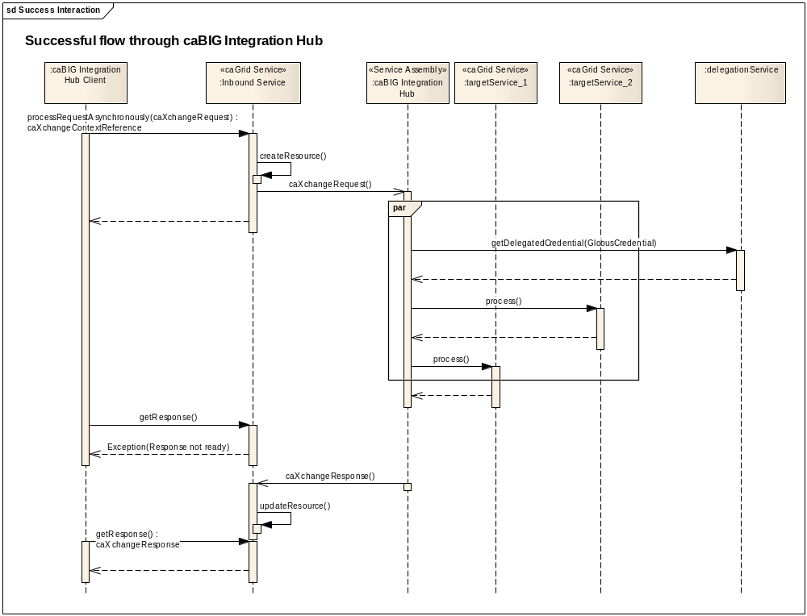
Figure 13 caBIG® Integration Hub Successful Flow Sequence Diagram
The following is a detailed flow through the caBIG® Integration Hub service assembly:
- The caBIG® Integration Hub Grid Service receives a request and creates a resource associated with the request.
- The grid service sends back an EPR associated with the resource to the client, which the client uses to check the status of the request.
- The caBIG® Integration Hub Grid Service then puts the request into the JMS queue from where it is picked up by the caBIG® Integration Hub Service Assembly.
- caBIG® Integration Hub Service Assembly validates the request payload against the schema registered for the service payload namespace. caBIG® Integration Hub caches the schemas from Global Model Exchange for payload validation.
- caBIG® Integration Hub Service Assembly invokes the delegation service for the credentials of the request, which is forwarded to all the target endpoints.
- If none of the target endpoints report any problem, then responses are aggregated and sent back to the client.

Rollback Flow Sequence Diagram
The sequence for a rollback interaction with caBIG® Integration Hub is depicted below.
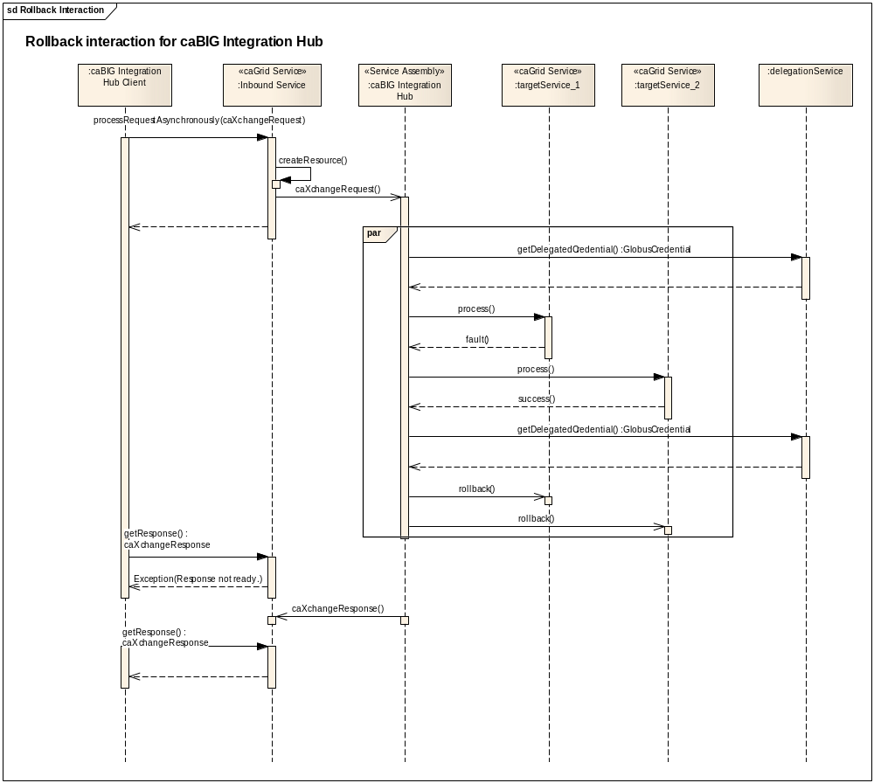
Figure 14 caBIG® Integration Hub: Rollback Sequence Diagram
The following is a detailed interaction within caBIG® Integration Hub service assembly:
- The inbound service receives a request and creates a resource associated with the request.
- The grid service sends back an EPR associated with the resource to the client, which it uses to check the status of the request.
- The inbound service then puts the request into the JMS queue from where it is picked up by the caBIG® Integration Hub service assembly.
- The caBIG® Integration Hub service assembly invokes the delegation service for the credentials of the request, which is forwarded to all the target endpoints.
- If any target endpoints reports any problems, then a rollback is sent to all the target endpoints.
- All of the responses are aggregated and sent back to the client along with a FAILURE status.

Deployment Diagram
The following depicts the deployment diagram for the caBIG® Integration Hub components.
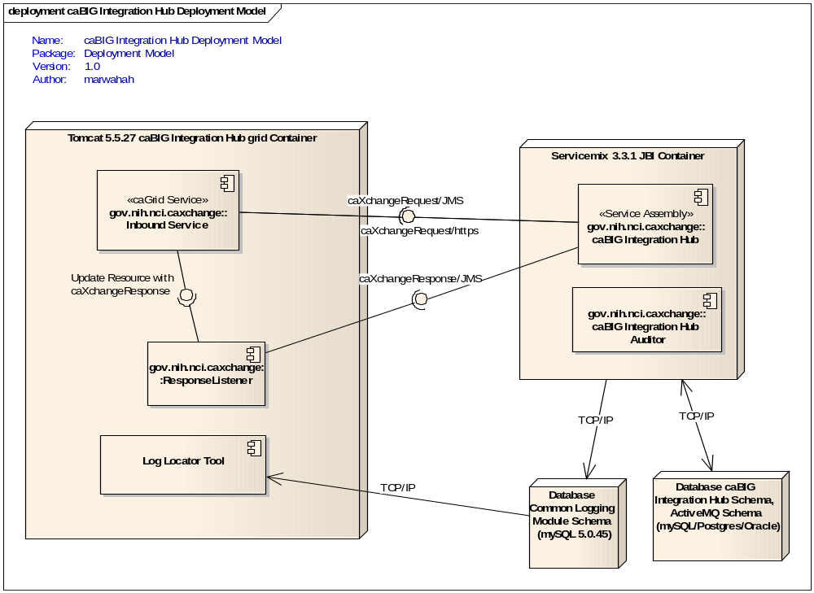
Figure 15 - caBIG® Integration Hub Deployment Diagram

Technology Stack
The following technologies are used in the caBIG® Integration Hub solution or in the development of the solution:
- JDK 1.5.10
- Apache ServiceMix 3.3.1
- Apache Ant 1.7
- mySQL 5.0.45
- Oracle 10.2
- Postgres 8.2.11
- Apache Tomcat 5.5.27
- Maven 2.0.8
- Enterprise Architect 7.1+
- caGrid 1.3
Extensive instructions on the installation and configuration of the core software components used in the caBIG® Integration Hub solution are covered in the caBIG® Integration Hub Installation Guide, located along with all the other caBIG® Integration Hub project deliverables at:
https://ncisvn.nci.nih.gov/svn/cabigintegrationhub/trunk/docs/Deliverables/

Appendix A References

Technical Manuals/Articles
- National Cancer Institute. “caCORE SDK 3.2 Programmers Guide”: http://ncicb.nci.nih.gov/infrastructure/cacoresdk
- Java Bean Specification: http://java.sun.com/products/javabeans/docs/spec.html
- Object-Relational Mapping articles and products: http://www.service-architecture.com/object-relational-mapping/
- Hibernate Reference Documentation: http://www.hibernate.org/hib_docs/reference/en/html/
- Basic O/R Mapping: http://www.hibernate.org/hib_docs/reference/en/html/mapping.html
- Java Programming: http://java.sun.com/learning/new2java/index.html
- Javadoc tool: http://java.sun.com/j2se/javadoc/
- Junit: http://junit.sourceforge.net/
- Extensible Markup Language: http://www.w3.org/TR/REC-xml/
- XML Metadata Interchange: http://www.omg.org/technology/documents/formal/xmi.htm

caBIG® Material
- caBIG®: http://caBIG.nci.nih.gov/
- caBIG® Compatibility Guidelines: http://cabig.nci.nih.gov/guidelines_documentation

caCORE Material
- caCORE: http://ncicb.nci.nih.gov/NCICB/infrastructure
- caBIO: https://wiki.nci.nih.gov/display/caBIO/caBIO+Wiki+Home+Page
- caDSR: http://ncicb.nci.nih.gov/NCICB/infrastructure/cacore_overview/cadsr
- EVS: http://ncicb.nci.nih.gov/NCICB/infrastructure/cacore_overview/vocabulary
- CSM: https://cabig.nci.nih.gov/tools/CSM
Appendix B Glossary
Term | Definition
{jboss-home} | The base directory where Jboss is installed on the server
API | Application Programming Interface
caBIG® | cancer Biomedical Informatics Grid
caBIO | Cancer Bioinformatics Infrastructure Objects
caCORE | cancer Common Ontologic Representation Environment
cardinality | Cardinality describes the minimum and maximum number of associated objects within a set
CDISC | Clinical Data Interchange Standards Consortium
CSM | Common Security Module
CTMS | Clinical Trial Management Systems
CVS | Concurrent Versions System
DAO | Data Access Objects
DAS | Distributed Annotation System
EA | Enterprise Architect
EBI | European Bioinformatics Institute
EVS | Enterprise Vocabulary Services
GULCCC | Georgetown University Lombardi Cancer Center
HIPPA | Health Insurance Portability and Accountability Act
HTTP | Hypertext Transfer Protocol
ISO | International Organization for Standardization
JAAS | Java Authentication and Authorization Service
JAR | Java Archive
Javadoc | Tool for generating API documentation in HTML format from doc comments in source code (http://java.sun.com/j2se/javadoc/)
JBI | Java Business Integration
JDBC | Java Database Connectivity
JET | Java Emitter Templates
JMI | Java Metadata Interface
JSP | JavaServer Pages
JUnit | A simple framework to write repeatable tests (http://junit.sourceforge.net/)
LDAP | Lightweight Directory Access Protocol
LLT | Log Locator Tool
LOINC | Logical Observation Identifier Names and Codes
MedDRA | Medical Dictionary for Regulatory Activities
metadata | Definitional data that provides information about or documentation of other data.
Multiplicity | Multiplicity of an association end indicates the number of objects of the class on that end may be associated with a single object of the class on the other end
NCI | National Cancer Institute
NCICB | National Cancer Institute Center for Bioinformatics
OMG | Object Management Group
ORM | Object Relational Mapping
RDBMS | Relational Database Management System
SDK | Software Development Kit
Semantic connector | A development kit to link model elements to NCICB EVS concepts.
SIG | Special Interest Group
SQL | Structured Query Language
UI | User Interface
UID | User Identification
UML | Unified Modeling Language
UMLS | Unified Medical Language System
UPT | User Provisioning Tool
URL | Uniform Resource Locators
WAR | Web Application Archive
WSDL | Web Services Description Language
XMI | XML Metadata Interchange (http://www.omg.org/technology/documents/formal/xmi.htm) - The main purpose of XMI is to enable easy interchange of metadata between modeling tools (based on the OMG-UML) and metadata repositories (OMG-MOF) in distributed heterogeneous environments
XML | Extensible Markup Language (http://www.w3.org/TR/REC-xml/) - XML is a subset of Standard Generalized Markup Language (SGML). Its goal is to enable generic SGML to be served, received, and processed on the Web in the way that is now possible with HTML. XML has been designed for ease of implementation and for interoperability with both SGML and HTML

Index

Components, 43
Deployment Diagram, 44
Document Conventions, 10
Features, 12, 13
Grid, 10, 47
hub, 23
Installation, 15, 45
Logic Blaze Fuse, 13
Process Flow, 26
requirements, 10, 13
Security, 47
Web Services, 48
WSDL, 42, 48

